O’Neill Healthcare Bay Village – Assisted Living |  |  | 9:00 Morning Greeting /  Daily Chronicle Delivery  10:00 Exercise  10:30 Coffee and Cookies  11:00 Basket Pong  1:30 Puzzle Table  2:00 Little Library Pass  3:30 Popcorn Cart  6:00 Snack Cart | 9:00 Morning Greeting /  Daily Chronicle Delivery  10:00 Hairdresser  10:00 Exercise  11:00 Pet Visits with  Clover and Nancy!  1:30 Rummy Game  2:30 Fall Craft - Pumpkins  3:30 Porch Visits | 9:00 Morning Greeting /  Daily Chronicle Delivery  10:00 Exercise  10:30 Coffee and Donuts  11:00 Menu Help  1:30 Puzzle Table  2:00 Bingo!  3:30 Soda Cart | 9:00Morning Greeting /  Daily Chronicle Delivery  10:00 Exercise  10:30 Coffee and Cookies  11:00 Today in History  2:00 Ice Cream Sandwich Cart  3:30 Porch Visits/Outdoor Walking Group
9:00 Morning Greeting /  Daily Chronicle Delivery  10:00 EWTN Catholic TV  Mass  10:30 Coffee Cart  2:00 Bible Study with  Jonathon - AL Activities RM  3:30 Adult Coloring Pages/Leisure Activities | 9:00 Morning Greeting /  Daily Chronicle Delivery  9:30 Resident Shopping  10:00 Communion Visits with Holy Spirit Catholic Church  1:30 Exercise  2:00 Bingo!  3:30 Hangman | 9:00 Morning Greeting /  Daily Chronicle Delivery  10:00 Exercise  10:30 Coffee/Conversation  11:00 Nail Care  1:30 Yahtzee  2:30 What’s Cooking- Pumpkin Pancakes (AL Café)  3:30 Catholic Rosary | 9:00 Morning Greeting /  Daily Chronicle Delivery  10:00 Exercise  10:30 Coffee and Cookies  11:00 Today in History  1:30 Yahtzee Game  2:30 Armchair Travel – California Dreamin’  3:30 Reminiscing Game  6:00 Snack Cart | 9:00 Morning Greeting /  Daily Chronicle Delivery  10:00 Hairdresser  10:00 Exercise  10:30 Coffee / Conversation  11:00 Pet Visits with  Clover and Nancy!  2:00 Music and Happy Hour with Gordon Taylor!  3:30 Lucky Duck Card Game | 9:00 Morning Greeting/  Daily Chronicle Delivery  10:00 Exercise  10:30 Coffee and Donuts  11:00 Menu Help  1:30 Puzzle  2:00 Bingo!  3:30 Lemonade Cart | 9:00Morning Greeting /  Daily Chronicle Delivery  10:00 Exercise  10:30 Coffee and Cookies  11:00 Trivia  2:00 Fall Craft - Lollipop Witches!  3:30 Porch Visits/Music
9:00 Morning Greeting /  Daily Chronicle Delivery  10:00 EWTN Catholic TV  Mass  10:30 Coffee Cart  2:00 Golden Treasures  Bible Study - AL Activities RM  3:30 Adult Coloring Pages/Leisure Activities | 9:00 Morning Greeting /  Daily Chronicle Delivery  10:00 Board of Elections Voting - U3 Dining Rm  10:00 Communion visits with Holy Spirit Catholic Church  10:00 Exercise  11:00 Outing to Paris Baguette!  2:00 Bingo! | 9:00 Morning Greeting /  Daily Chronicle Delivery  10:00 Exercise  10:30 Coffee/Conversation  11:00 Trivia – Crazy Horse Memorial  2:00 Fall Memorial Service -  Front Lobby NH  3:30 Catholic Rosary | 9:00 Morning Greeting /  Daily Chronicle Delivery  10:00 Exercise  10:30 Coffee and Cookies  11:00 Funny Animal Videos  1:30 Rummy Game  2:30 Little Library Pass  3:30 Iced Tea Cart  6:00 Snack Cart | 9:00 Morning Greeting /  Daily Chronicle Delivery  10:00 Hairdresser  10:00 Exercise  10:30 Coffee / Conversation  11:00 Pet Visits with  Clover and Nancy!  1:30 Wordsearch Finds  2:00 Bingo!  3:30 Porch Visits | 9:00 Morning Greeting/  Daily Chronicle Delivery  10:00 Preschool Trick or Treat Event  10:30 Refreshments/Donuts  1:30 Puzzle Table  2:00 Music and Happy Hour with Dan Elish!  3:30 Menu Help | 9:00Morning Greeting /  Daily Chronicle Delivery  10:00 Exercise  10:30 Coffee and Cookies  11:00 Word Games  2:00 Bingo!  3:30 Porch Visits/Music
9:00 Morning Greeting /  Daily Chronicle Delivery  10:00 EWTN Catholic TV  Mass  10:30 Coffee Cart  2:00 Bible Study with  Jonathon - AL Activities RM  3:30 Adult Coloring Pages/Leisure Activities | 9:00 Morning Greeting /  Daily Chronicle Delivery  10:00 Communion Visits with  Holy Spirit Catholic Church  10:00 Exercise  10:30 Coffee and Conversation  11:00 Nail Care  1:30 Puzzle Table  2:00 Bingo!  3:30 Word Games | 9:00 Morning Greeting /  Daily Chronicle Delivery  10:00 Exercise  10:30 Coffee/Conversation  11:00 Lunch Outing -  Texas Roadhouse!  2:00 Resident Council  3:30 Catholic Rosary | 9:00 Morning Greeting /  Daily Chronicle Delivery  10:00 Exercise  10:30 Coffee and Cookies  11:00 Today in History  1:30 Yahtzee  2:30 Porch Visits  3:30 Popcorn Cart  6:00 Snack Cart | 9:00 Morning Greeting /  Daily Chronicle Delivery  10:00 Hairdresser  10:00 Exercise  10:30 Coffee / Conversation -  Fall Traditions!  11:00 Pet Visits with  Clover and Nancy!  2:00 Apple Tasting Social  5:30 Annual Trick or Treat Event! | 9:00 Morning Greeting/  Daily Chronicle Delivery  10:00 Exercise  10:30 Coffee and Donuts  11:00 Menu Help  1:30 Puzzle Table  2:00 Happy Hour and Piano Music with Barb!  3:30 Lemonade Cart  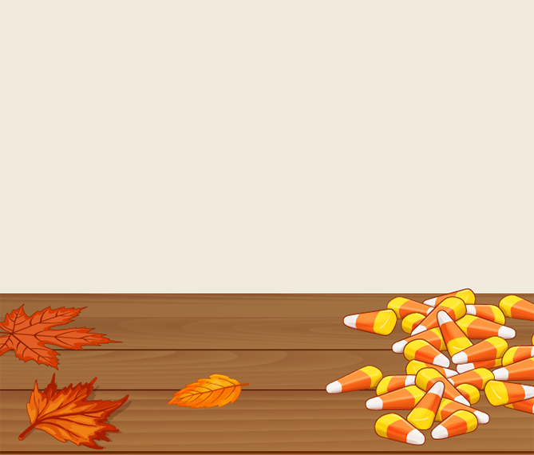 | :00Morning Greeting /  Daily Chronicle Delivery  10:00 Exercise  10:30 Coffee and Cookies  1:30 Porch Visits  2:00 Halloween Movie Matinee & Popcorn!  3:30 Porch Visits/Outdoor Walking Group
9:00 Morning Greeting /  Daily Chronicle Delivery  10:00 EWTN Catholic TV  Mass  10:30 Coffee Cart  2:00 Golden Treasures  Bible Study - AL Activities RM  3:30 Adult Coloring Pages/Leisure Activities | 9:00 Morning Greeting /  Daily Chronicle Delivery  10:00 Communion Visits with  Holy Spirit Catholic Church  10:00 Exercise  10:30 Coffee and Conversation  11:00 Trivia - Witches and Witchcraft  1:30 Puzzle Table  2:00 Bingo!  3:30 Lemonade Cart | 9:00 Morning Greeting /  Daily Chronicle Delivery  10:00 Exercise  10:30 Coffee/Conversation  11:00 Nail Care  1:30 Rummy  2:30 What’s Cooking- Halloween Cake Pops (AL Café)  3:30 Catholic Rosary | 9:00 Morning Greeting /  Daily Chronicle Delivery  10:00 Exercise  10:30 Coffee and Cookies  11:00 America’s Funniest Videos  1:30 Poker  2:30 Armchair Travel - Wonders of New England  3:30 Old Maid Card Game  6:00 Snack Cart | 9:00 Morning Greeting /  Daily Chronicle Delivery  10:00 Hairdresser  10:00 Exercise  10:30 Coffee / Conversation  11:00 Pet Visits with  Clover and Nancy!  1:30 Puzzle Table  2:00 Bingo!  3:30 UNO Card Game | 9:00 Morning Greeting/  Daily Chronicle Delivery  10:00 Exercise  10:30 Coffee and Donuts  11:00 Menu Help  1:30 Puzzle Table  2:00 Halloween/October Birthday Party!  3:30 Halloween Candy Cart | *Activities are Subject to Change. Please refer to the daily sheet for any changes. Thank you! *
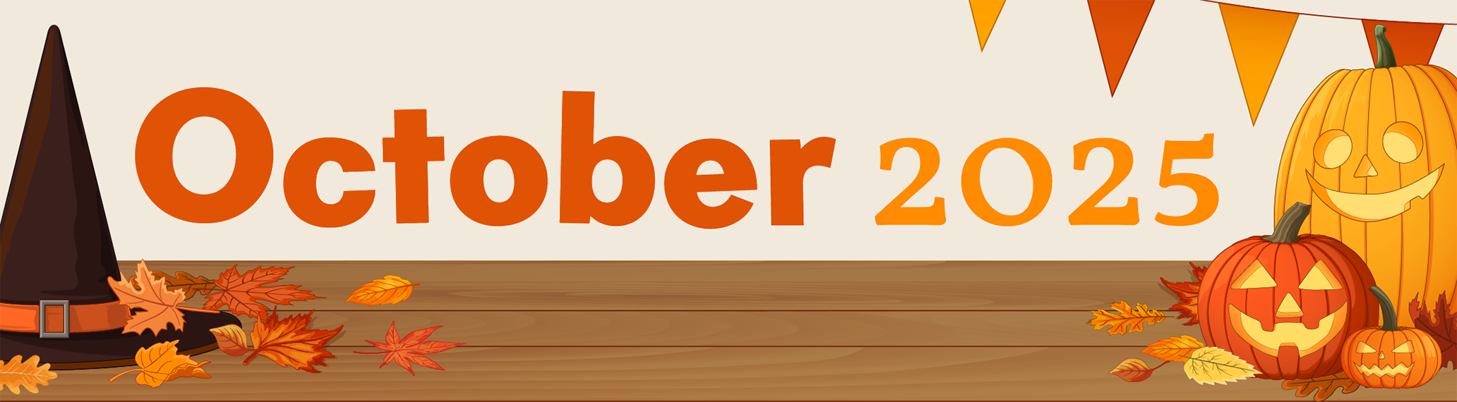
605 Bradley Road Bay Village, Ohio 44140
Sunday | Monday | Tuesday | Wednesday | Thursday | Friday | Saturday
 |  |  | 1  Yom Kippur Begins | 2 | 3 | 4
5 | 6  Sukkot Begins | 7 | 8 | 9 | 10 | 11
12 | 13  Thanksgiving Day (Canada)  Indigenous Peoples’ Day  Columbus Day (U.S.) | 14  Simchat Torah Begins | 15 | 16 | 17 | 18
19 | 20 | 21 | 22 | 23 | 24 | 25
26 | 27 | 28 | 29 | 30 | 31  Halloween

