|  |  |  |  |  |  |  |  |  |
| --- | --- | --- | --- | --- | --- | --- | --- | --- |
|  |  | |  | |  |  |  |  |
| **Please speak with activities staff to check outing availability. Activities are subject to change.**  **Please check daily activities sheets for any updates. Thank you!** | | 9:00 Morning Greeting/Daily Chronicle Delivery  10:00 Exercise  10:30 Coffee Club/Chat  11:00 Today in History  1:45 Fruit Punch  **2:00 Labor Day Bingo!**  4:00 Music Mondays | | 9:00 Morning Greeting/Daily Chronicle Delivery  10:00 Exercise  10:30 Coffee Club/Chat  11:00 Rock and Roll Hall of Fame Anniversary  1:15 Sunflower Craft  **2:00 Orthodox Church Service with Gerald** | 9:00 Morning Greeting/Daily Chronicle Delivery  10:00 Exercise  10:30 Coffee Club/Chat  11:00 Menu Pass  1:30 Pet Visits with Clover!  2:00 Jeopardy!  **3:00 Bay United Methodist Church Service (U3)**  5:30 Independent Crafts – U3 | 9:00 Morning Greeting/Daily Chronicle Delivery  10:00 Exercise  10:30 Coffee Club/Chat  11:00 1:1 Menu Help  1:30 Pet Visits with Clover & Nancy!  **2:00 Movie Matinee – Harry Potter!**  3:30 Residents Choice! | 9:00 Morning Greeting/Daily Chronicle Delivery  10:00 Exercise  10:30 Coffee + Donuts  11:00 1:1 Menu Help  1:45 Refreshments!  **2:00 Bingo!**  4:00 Puzzles & Crosswords (U3) | 9:00 Morning Greeting/Daily Chronicle Delivery  10:00 Saturday Stretches!  10:30 Coffee Club/Chat  2:00 Name That Tune  **2:30 Coffee Ice Cream Day!**  3:30 Hallway Happenings |
| 9:00 Morning Greeting/Daily Chronicle Delivery  10:30 Coffee Club/Chat  11:00 Grandparents Day Chat  1:00 Browns v. Bengals (U3)  **2:00 Bible Study with Jonathan – AL Activities RM**  2:30 Ice Cream Social | 9:00 Morning Greeting/Daily Chronicle Delivery  10:00 Communion  10:00 Exercise  10:30 Coffee Club/Chat  11:00  1:30 Refreshments!  **2:00 Grow a Pet Day – Chia Pet Anniversary**  4:00 Music Mondays | | 9:00 Morning Greeting/Daily Chronicle Delivery  10:00 Exercise  10:30 Coffee Club/Chat  **11:00 Lunch Outing to Applebee’s!**  1:45 Outdoor/Garden Group  **3:30 Annual Dog Show (AL)**  4:30 Cookout Dinner! | | 9:00 Morning Greeting/Daily Chronicle Delivery  10:00 Exercise  10:30 Coffee Club/Chat  11:00 Menu Pass  1:30 Door to Door Visits  2:00 Word Game Wednesday  **2:30 Happy Birthday Arnold Palmer Social**  5:30 Independent Crafts – U3 | 9:00 Morning Greeting/Daily Chronicle Delivery  10:00 Exercise  10:30 Coffee Club/Chat  11:00 1:1 Menu Help  1:00 Pet Visits with Clover & Nancy!  **2:00 Oktoberfest with the Polka Pirates! (AL)**  3:30 Residents Choice! | 9:00 Morning Greeting/Daily Chronicle Delivery  10:00 Exercise  10:30 Coffee + Donuts  11:00 1:1 Menu Help  1:45 Refreshments!  **2:00 Bingo!**  4:00 Puzzles & Crosswords (U3) | 9:00 Morning Greeting/Daily Chronicle Delivery  10:00 Saturday Stretches!  10:30 Coffee Club/Chat  2:00 Trivia!  **2:30 Cornhole & Foam Darts**  3:30 Hallway Happenings |
| 9:00 Morning Greeting/Daily Chronicle Delivery  10:30 Coffee Club/Chat  11:00 Who, What, Where?  1:00 Browns v. Ravens (U3)  **2:00 Golden Treasures Bible Study – AL Activities RM**  3:00 Pop Tarts Cart – Pop Tarts Anniversary | 9:00 Morning Greeting/Daily Chronicle Delivery  10:00 Communion  10:00 Exercise  10:30 Coffee Club/Chat  11:00 Guacamole Day  1:30 Refreshments!  **2:00 Paper Plate Leaves Craft**  4:00 Music Mondays | | 9:00 Morning Greeting/Daily Chronicle Delivery  10:00 Exercise  10:30 Coffee Club/Chat  11:00 Tuesday Trivia!  **2:00 Bingo!**  3:30 International Country Music Day! | | 9:00 Morning Greeting/Daily Chronicle Delivery  10:00 Exercise  10:30 Coffee Club/Chat  11:00 Menu Pass  1:30 Door to Door Visits  2:00 Constitution Day - Trivia  **2:30 Resident Council (U3)**  5:30 Independent Crafts – U3 | 9:00 Morning Greeting/Daily Chronicle Delivery  10:00 Exercise  10:30 Coffee Club/Chat  11:00 1:1 Menu Help  1:00 Pet Visits with Clover & Nancy!  **2:00 Apple Cider Social – Happy Apple Cider Month!**  3:30 Residents Choice! | 9:00 Morning Greeting/Daily Chronicle Delivery  10:00 Exercise  10:30 Coffee + Donuts  11:00 1:1 Menu Help  1:45 Refreshments!  **2:00 Bingo!**  4:00 Puzzles & Crosswords (U3) | 9:00 Morning Greeting/Daily Chronicle Delivery  10:00 Saturday Stretches!  10:30 Coffee Club/Chat  2:00 Name That Tune  **2:30 Pretzel and Cheese Social**  3:30 Hallway Happenings |
| 9:00 Morning Greeting/Daily Chronicle Delivery  10:30 Coffee Club/Chat  **11:30 Outing to Dairy Queen!**  1:00 Browns v. Packers (U3)  **2:00 Bible Study with Jonathan – AL Activities RM** | 9:00 Morning Greeting/Daily Chronicle Delivery  10:00 Communion  10:00 Exercise  10:30 Coffee Club/Chat  11:00 First Day of Autumn  1:30 Music Mondays  **2:00 Chocolate Milkshakes**  4:00 Milkshake Trivia | | 9:00 Morning Greeting/Daily Chronicle Delivery  10:00 Exercise  10:30 Coffee Club/Chat  11:00 Tuesday Trivia!  1:00 Pet Visits with Clover & Nancy!  **2:00 Bingo!**  3:30 Libra Day – Reading Daily Horoscopes | | 9:00 Morning Greeting/Daily Chronicle Delivery  10:00 Exercise  10:30 Coffee Club/Chat  11:00 Menu Pass  1:30 Door to Door Visits  **2:00 Monthly Birthday Party with Gordon Taylor!**  5:30 Independent Crafts – U3 | 9:00 Morning Greeting/Daily Chronicle Delivery  10:00 Exercise  10:30 Coffee Club/Chat  11:00 1:1 Menu Help  1:00 Band of Brothers  **2:00 Veterans Club (U3)**  3:30 One-Hit Wonder Day | 9:00 Morning Greeting/Daily Chronicle Delivery  10:00 Exercise  10:30 Coffee + Donuts  11:00 1:1 Menu Help  1:45 Refreshments!  **2:00 Bingo!**  4:00 Puzzles & Crosswords (U3) | 9:00 Morning Greeting/Daily Chronicle Delivery  10:00 Saturday Stretches!  10:30 Coffee Club/Chat  2:00 Trivia!  **2:30 Johnny Appleseed’s Birthday – Apples & History**  3:30 Hallway Happenings |
| 9:00 Morning Greeting/Daily Chronicle Delivery  10:30 Coffee Club/Chat  11:00 Who, What, Where?  1:00 Browns v. Lions (U3)  **2:00 Golden Treasures Bible Study – AL Activities RM**  2:30 Ice Cream Cart | 9:00 Morning Greeting/Daily Chronicle Delivery  10:00 Communion  10:00 Exercise  10:30 Coffee Club/Chat  11:00 “Yabba Dabba Doo!” Day  1:30 Refreshments!  **2:00 Q-tip Fall Tree Craft**  4:00 Music Mondays | | 9:00 Morning Greeting/Daily Chronicle Delivery  10:00 Exercise  10:30 Coffee Club/Chat  11:00 Tuesday Trivia!  **2:00 Bingo!**  3:30 Frisbee Day | | **O’Neill Healthcare Bay Village – Nursing Home** | | | |

605 Bradley Road Bay Village, Ohio 44140

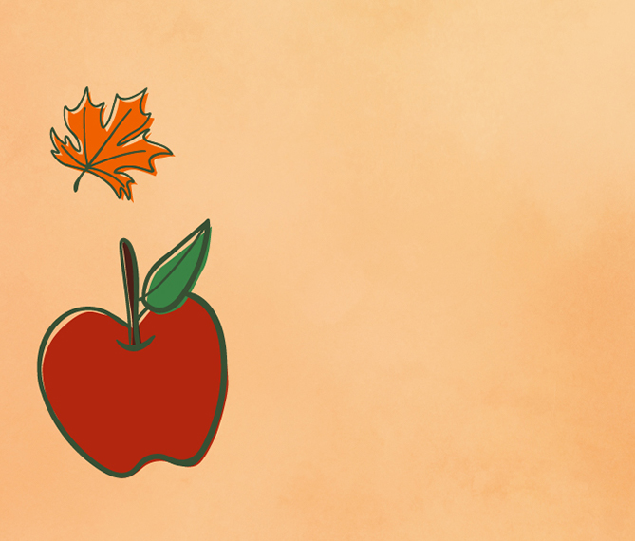

|  |  |  |  |  |  |  |
| --- | --- | --- | --- | --- | --- | --- |
| Sunday | Monday | Tuesday | Wednesday | Thursday | Friday | Saturday |
|  | **1** Labor Day | **2** | 3 | 4 | 5 | 6 |
| **7** Grandparents Day | 8 | 9 | 10 | 11 | 12 | 13 |
| 14 | 15 | 16 | 17 | 18 | 19 | **20** Oktoberfest Begins |
| 21 | **22**  Rosh Hashanah Begins Autumn Begins | 23 | 24 | 25 | 26 | 27 |
| 28 | 29 | 30 |  | | | |

sssssssssss