Sunday | Monday | Tuesday | Wednesday |  | Thursday | Friday | Saturday
 |  |  |  | 1  Yom Kippur Begins  cccZ | 2 | 3 | 4
5 | 6  Sukkot Begins | 7 |  | 8 | 9 | 10 | 11
12 | 13  Thanksgiving Day (Canada)  Indigenous Peoples’ Day  Columbus Day (U.S.) | 14  Simchat Torah Begins |  | 15 | 16 | 17 | 18
19 | 20 | 21 |  | 22 | 23 | 24 | 25
26 | 27 | 28 |  | 29 | 30 | 31  Halloween

 |  |  | 9:30 Daily Chronicle/Puzzle Pass  10 Workout Wednesday  10:30 What’s The Buzz?  11 Remembering Julie Andrews Songs  1:30 Coloring Club  2 P.M. Bible Study  3 P.M. Games with Tammy (Across the Table) | 9:30 Daily Chronicle/Puzzle Pass  10 Polka Hits  10:30 Pretty Nails  2:30 Oktoberfest Music by the Polka Pirates. | 9:30 Daily Chronicle/ Puzzle Pass  10 Friday Fitness  (Balloon Bop)  11 Book Club  2 P.M. Popcorn Pass  3 P.M. BINGO! | 9:30 Daily Chronicle/Puzzle Pass  10:30 Moving to the Oldies  11 Football Trivia  2 P.M. ball swap  3 P.M. I Should Have Known That
9:30 Daily Chronicle/Puzzle Pass  9:30 Catholic Mass/Livestream from St. Angelas  10:30 Catholic Communion  11 Sip & Chat  1:30 Browns watch with Snacks  3 P.M. Shuffleboard pokensStarmomonthmonthMonth | 9:30 Daily Chronicle/Puzzle Pass  10 Movement Monday  11 Spanish Lesson with Rose  1:30 Sip & Chat  2 P.M. Pet Visit with Adele  3 P.M. Travel along  “California Dreamin” | 9:30 Daily Chronicle/Puzzle Pass  10 Menu Assistance  11 Catholic Rosary  1 P.M. Pet visit with Chico  2 P.M. Table Time (Three Piece Card Game)  3 P.M. BINGO!! | 9:30 Daily Chronicle/Puzzle Pass  10 Workout Wednesday  10:30 What’s The Buzz?  11 What Am I?  1:30 Coloring Club  2 P.M. Bible Study  3 P.M. Games with Tammy (Scram-bit) | 9:30 Daily Chronicle/Puzzle Pass  10 Julie Andrews Favorites  10:30 Pretty Nails  2 P.M. Memorial Service – North Dining Room  3 P.M. Reminisce on the Porch | 9:30 Daily Chronicle/ Puzzle Pass  10 Friday Fitness  (Kickball)  11 Book Club  1 P.M. Bunny Visit with Hank  2 P.M. Popcorn Pass  3 P.M. BINGO! | 9:30 Daily Chronicle/Puzzle Pass  10:30 Moving to the Oldies  11 Word within a Word  2 P.M. Crozzle  3 P.M. Skeetball
9:30 Daily Chronicle/Puzzle Pass  9:30 Catholic Mass/Livestream from St. Angelas  10:30 Catholic Communion  11 Sip & Chat  1:30 Browns Watch with Snacks  3 P.M. Who wants to be a Millionaire? | 9:30 Daily Chronicle/Puzzle Pass  10 Movement Monday  11 Indigenous People’s Day  Jeopardy Trivia  1:30 Sip & Chat  2 P.M. Pet Visit with Adele  3 P.M. Breast Cancer Awareness PINK DAY | 9:30 Daily Chronicle/Puzzle Pass  10 Menu Assistance  11 Catholic Rosary  1 P.M. Pet Visit with Chico  2 P.M. Table Time (What People Say)  3 P.M. BINGO!! | 9:30 Daily Chronicle/Puzzle Pass  10 Workout Wednesday  10:30 New Hope Church Service- Chapel  1:30 Coloring Club  2 P.M. Bible Study  3 P.M. Games with Tammy (Spooky Bowling) | 9:30 Daily Chronicle/Puzzle Pass  10 Chubby Checker Classics  10:30 Pretty Nails  2 P.M. Men’s Club- The Three -Peat Dice Game  3 P.M. Red Hat Society  3:30 Sensory Time- Roll A Pumpkin | 9:30 Daily Chronicle/ Puzzle Pass  10 Friday Fitness  (Chair Yoga)  11 Book Club  2 P.M. Popcorn Pass  3 P.M. BINGO! | 9:30 Daily Chronicle/Puzzle Pass  10:30 Moving to the Oldies  11 Star of the Month  2 P.M. Treats for Sweets  3 P.M. What’s the scoop?
9:30 Daily Chronicle/Puzzle Pass  9:30 Catholic Mass/Livestream from St. Angelas  10:30 Catholic Communion  11 Sip & Chat  1:30 Browns Watch with Snacks  3 P.M. Umbrella ball | 9:30 Daily Chronicle/Puzzle Pass  10 Movement Monday  11 Spanish Lesson with Rose  1:30 Sip & Chat  2 P.M. Pet Visit with Adele  3 P.M. Crafter’s Cove | 9:30 Daily Chronicle/Puzzle Pass  9:45 Intergenerational Visit  10 Menu Assistance  11 Catholic Rosary  2 P.M. Table Time (High Roller)  3 P.M. BINGO!! | 9:30 Daily Chronicle/Puzzle Pass  10 Workout Wednesday  10:30 What’s The Buzz?  11 Happy/Grumpy Balloon Toss  1:30 Coloring Club  2 P.M. Bible Study  3 P.M. Games with Tammy (1000 to 0) | 9:30 Daily Chronicle/Puzzle Pass  10 The best of Paul Simon  10:30 Pretty Nails  2 P.M. Halloween would you rather?  Trunk or Treat 6-7 P.M. | 9:30 Daily Chronicle/ Puzzle Pass  10 Friday Fitness  (Music Jam)  11 Book Club  1 P.M. Bunny Visit with Hank  2 P.M. Popcorn Pass  3 P.M. BINGO! | 9:30 Daily Chronicle/Puzzle Pass  10:30 Moving to the Oldies  11 Which word is it?  2 P.M. Tic Tac Whoa  3 P.M. Table Hockey
9:30 Daily Chronicle/Puzzle Pass  9:30 Catholic Mass/Livestream from St. Angelas  10:30 Catholic Communion  11 Sip & Chat  1:30 Browns Watch with Snacks  3 P.M. Drama Club | 9:30 Daily Chronicle/Puzzle Pass  10 Movement Monday  11Short Story “Bethany Gets Booed “  1:30 Sip & Chat  2 P.M. Pet Visit with Adele  3 P.M. Cooking Club | 9:30 Daily Chronicle/Puzzle Pass  10 Menu Assistance  11 Catholic Rosary  1 P.M. Pet Visit with Chico  2 P.M. Table Time (Who Did It?  3 P.M. Witch Bingo! | 9:30 Daily Chronicle/Puzzle Pass  10 Workout Wednesday  10:30 What’s The Buzz?  11m Oat meal Facts  1:30 Coloring Club  2 P.M. Bible Study (Special Guest Speaker Lolita Jones- Chapel  3 P.M. Games with Tammy (Ghost Toss) | 9:30 Daily Chronicle/Puzzle Pass  10 Spooky Tunes  10:30 Pretty Nails  2 P.M. Resident Council/Food Committee-South DR  3 P.M. Monthly Birthday Party (Halloween Edition) | 9:30 Daily Chronicle/ Puzzle Pass  10 Friday Fitness  11 Book Club  2 P.M. Popcorn Pass  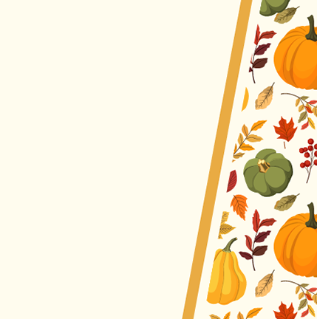  3 P.M. Popcorn Bingo | Any Calendar  Changes Will  Be Posted
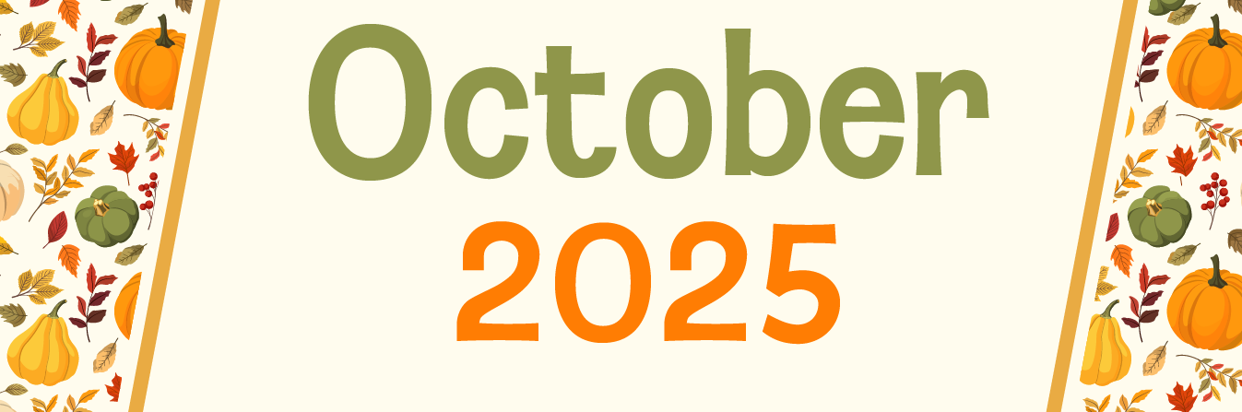
O’Neill Healthcare FP 440.331.0300

