O’Neill Health Care Assisted Living (Lakewood) |  |  | 9:15 Seated Exercise  9:35 Morning Coffee  10:15 Halloween Decorating  11:00 Protestant Service (SNF)  1:30 Nickle LCR (45 CENTS)  3:00 DIY: Autumn Water Colors | 9:15 Seated Exercise  9:35 Morning Coffee  10:15 Cooking Club: Pumpkin spice cupcakes  1:30 Chip Bingo  3:00 Ice cream Social | 9:15 Seated Exercise  9:35 Morning Coffee  1:30 PYP Pokeno  3:00 Orthodox Service (SNF)  3:00 Happy Hour  6:00-6:50 Activity Cart | 9:30 Morning Coffee and Cinnamon Buns  9:45 Uno  10:30-11:30 Activity Cart  1:30 Quarter Bingo  3:00 Craft  4:30 Popcorn to go (DR)
9:45 Morning Coffee and Cookies  10:30 Rosary w/ Jess  11:00 Bible Verse w/ Roger  1:30 Hearts  3:15 The Chosen | 9:15 Seated Exercise  9:35 Morning Coffee  10:15 Pumpkin Decorating Contest  1:30 Wii Bowling  3:00 Candy bar Bingo (6) | 9:30 Outing: Dollar Tree  10:15 Cooking club: Chocolate Covered Pretzels  1:30 Dime Pokeno (5)  3:00 Catholic Mass (SNF) | 9:15 Seated Exercise  9:35 Morning Coffee  10:15 Cards Against Humanity  11:00 Protestant Service (SNF)  1:30 Hearts  3:00 DIY: Wooden Pumpkin Houses | 9:15 Seated Exercise  9:35 Morning Coffee  10:45 Bible study w/ Ron (SNF)  1:30 Chip Bingo (6)  2:00 Zumba (SNF)  3:00 3:00 Ice cream Social | 9:15 Seated Exercise  9:35 Morning Coffee  1:30 Candy bar Pokeno  3:00 Happy Hour  6:00-6:50 Activity Cart | 9:30 Morning Coffee  9:45 Tongue Twisters  10:30-11:30 Activity Cart  1:30 Quarter Bingo  3:00 Cooking Club: Rice Krispy Treats
9:45 Morning Coffee and Cookies  10:30 Rosary w/ Jess  11:00 Bible Verse w/ Roger  1:30 Rummy  3:15 The Chosen | 9:15 Seated Exercise  9:35 Morning Coffee  1:30 Wii Bowling  2:00 Memorial Service (SNF)  3:00 Candy bar Bingo (6) | 9:15 Seated Exercise  9:35 Morning Coffee  1:30 Dime Pokeno (5)  3:00 Darts and Music  4:00 Take out Tuesday: King Hibachi | 9:15 Seated Exercise  9:35 Morning Coffee  10:15 Cooking Club: TBA  11:00 Protestant Service (SNF)  1:30 Outing: Scenic Ride Thru’ The Valley | 9:15 Seated Exercise  9:35 Morning Coffee  10:15 DIY: Paper Bouquets  1:30 Chip Bingo (6)  3:00 Ice cream Social | 9:15 Seated Exercise  9:35 Morning Coffee  1:30 PYP Pokeno  3:00 Happy Hour  6:00-6:50 Activity Cart | 9:30 Morning Coffee  9:45 Mad Libs  10:30-11:30 Activity Cart  1:30 Quarter Bingo  2:30 Saturday Sing (SNF)  3:00 Mobile Soda Station  4:30 Dinner Trivia (World History)
9:45 Morning Coffee and Cookies  10:30 Rosary w/ Jess  11:00 Bible Verse w/ Roger  1:30 Yahtzee  3:15 The Chosen | 9:15 Seated Exercise  9:35 Morning Coffee  10:15 Bible Study w/ Erin  1:30 Wii Bowling  3:00 Candy bar Bingo (6) | 9:15 Seated Exercise  9:35 Morning Coffee  10:15 DIY: Leaf Pressing  1:30 Dime Pokeno (5)  3:00 Taco Tuesday! (build your own Taco Bowl) | 9:15 Seated Exercise  9:35 Morning Coffee  10:00 Cooking Club: Calzones  11:00 Protestant Service (SNF)  1:30 PYP Lucky Cards (7) | 9:15 Seated Exercise  9:35 Morning Coffee  12:30 Outing: Lunch @ Fathead’s  5:00-6:00 Trick or Treat! (DR) | 9:15 Seated Exercise  9:35 Morning Coffee  1:30 Candy Bar Pokeno  3:00 Happy Hour/October Birthday Party  3:00 Orthodox Service (SNF)  6:00-6:50 Activity Cart | 9:30 Morning Coffee and cinnamon rolls  10:30-11:30 Activity Cart  1:30 Quarter Bingo  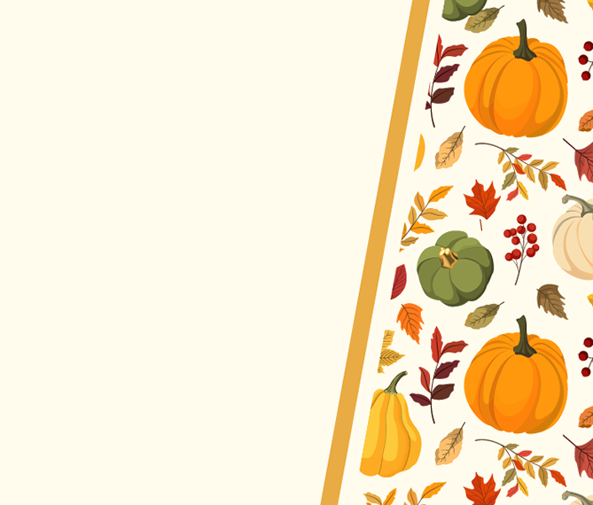  3:00 Autumn Craft  4:30 Dinner Trivia (Science)
9:45 Morning Coffee and Cookies  10:30 Rosary w/ Jess  11:00 Bible Verse w/ Roger  1:30 Rummy  3:15 The Chosen | 9:15 Seated Exercise  9:35 Morning Coffee  10:00 Pet Memorial  1:30 Wii Bowling  3:00 Candy bar Bingo (6) | 9:15 Seated Exercise  9:35 Morning Coffee  10:15 Resident Council  1:30 Dime Pokeno (5)  3:00 Snack Social and Karaoke  3:00 Catholic Mass (SNF) | 9:15 Seated Exercise  9:35 Morning Coffee  11:00 Protestant Service (SNF)  12:00 Music w/ Dan Elish (DR)  1:30 Uno!  3:00 Craft | 9:15 Seated Exercise  9:35 Morning Coffee  10:00 Would you Rather?  2:00 Gospel w/ Lolita  2:00 Halloween Party | 9:15 Seated Exercise  9:35 Morning Coffee  1:30 Chip Pokeno  3:00 Happy Hour  4:45 Dinner Time Trivia  6:00-6:50 Activity Cart  *9:30-4:00 Vermilion Day Trip | All activities are subject to change
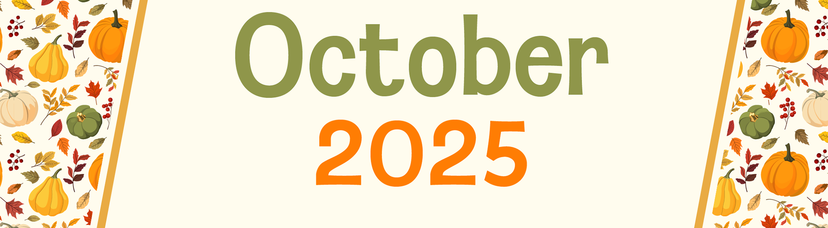
Type the name, address, and other information about your community/company here.
Sunday | Monday | Tuesday | Wednesday | Thursday | Friday | Saturday
 |  |  | 1  Yom Kippur Begins | 2 | 3 | 4
5 | 6  Sukkot Begins | 7 | 8 | 9 | 10 | 11
12 | 13  Thanksgiving Day (Canada)  Indigenous Peoples’ Day  Columbus Day (U.S.) | 14  Simchat Torah Begins | 15 | 16 | 17 | 18
19 | 20 | 21 | 22 | 23 | 24 | 25
26 | 27 | 28 | 29 | 30 | 31  Halloween

