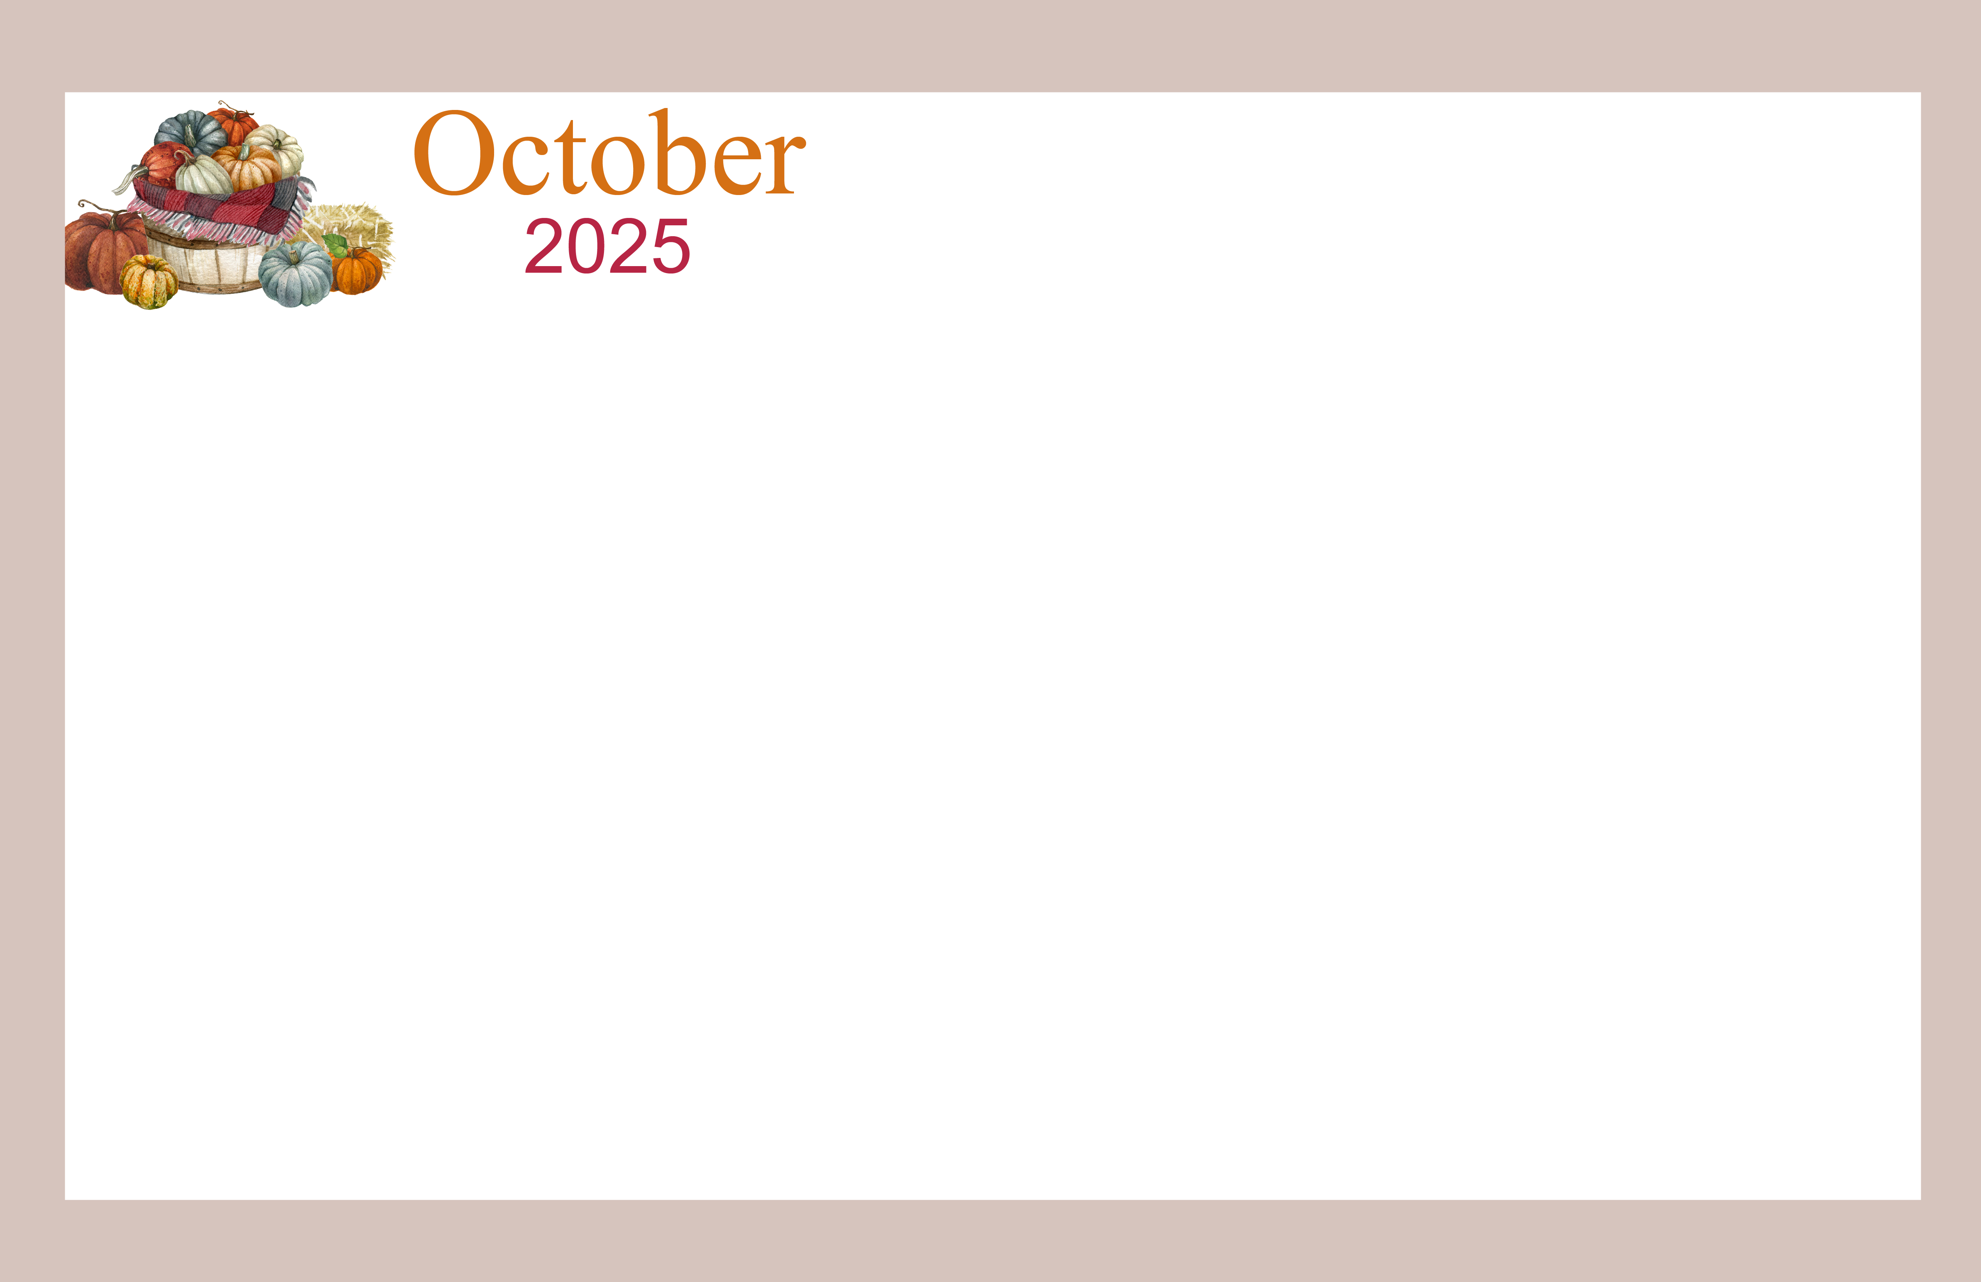  O’Neill Healthcare of Lakewood |  |  | 9:30 Cookies & Chronicles-1  10:15 Daily News & Coffee  11:00-12:00 Protestant  Service  12:00 Today in History  2:00 Music with Dan  3:00 Dietary Week Project | 9:30 Cookies & Chronicles-1  10:30 Daily News & Coffee  11:00 Exercise  11:30 Boggle  12:00 Today in History  (in-rooms)  2:00 Bingo  3:00 Famous Faces | 9:30 Cookies & Chronicles-1  10:00 Daily News & Coffee  10:30 Hedbandz  11:00 Cornhole  12:00 Today in History  (in-rooms)  2:00 Steal the  Old Mans Bundle  3:00 Orthodox Service  4:00 In-room Prayer | 9:30 Coffee Hour  10:00 In the News  10:30 Word Game  11:00 Game On!  12:00 Daily Chronicle  12:30 Activity Cart 1st Fl  2:00 Exercise  2:30-3:30 Bingo
10:00 Morning Coffee  Cart & Donuts -1&2  11:00 In the News  11:30 Exercise  12:00 Daily Chronicle  2:00 Game On!  2:30-3:30 Lucky Cards | 9:30 Cookies & Chronicles-1  10:00 Daily News & Coffee  10:30-11:30 Bible Study  12:00 Today in History  (in-rooms)  2:00 Tea Party for  Mad Hatter Day  3:00 Manicures | 9:30 Cookies & Chronicles-1  10:00 Daily News & Coffee  10:30-11:30 Space Week:  Where Were You When…?  12:00 Today in History (in-rooms)  1:45 Shopping Trip Outing  2:00 Astronaut Snack Tasting  2:30 Book Club  3:00 Catholic Mass with  Fr. Peter-Paul  4:00 Room Visits  4:30 1:1 Menu Prep  6:00 Game Night  6:30 Movie Night | 9:30 Cookies & Chronicles-1  10:00 Voting w/ Assistance  from the BOE  10:15 Daily News & Coffee  12:00 Today in History  2:00 National Pierogi Day  2:30 Sing Along  3:30 This or That | 9:30 Cookies & Chronicles-1  10:00 Daily News & Coffee  10:45 Bible Study W/ Ron  12:00 Today in History  (in-rooms)  2:00 Zumba  3:00 Bingo | 9:30 Cookies & Chronicles-1  10:00 Daily News & Coffee  10:30 Word from A Word  11:00 Bowling  12:00 Today in History  (in-rooms)  2:00 Packing Bags for World  Homeless Day  3:00 Spooky Crafting | 9:30 Coffee Hour  10:00 In the News  10:30 Word Game  11:00 Game On!  12:00 Daily Chronicle  12:30 Activity Cart 1st Fl  2:00 Exercise  2:30-3:30 Bingo
10:00 Morning Coffee  Cart & Donuts -1&2  11:00 In the News  11:30 Exercise  12:00 Daily Chronicle  1:00 Browns Vs. Steelers  Football Game  2:00 Halftime Tailgate Party  3:00 Browns Football Trivia | 9:30 Cookies & Chronicles-1  10:00 Daily News & Coffee  10:30-11:30 Bible Study  12:00 Today in History  (in-rooms)  2:00 Memorial Service  (1st Fl DR) | 9:30 Cookies & Chronicles-1  10:00 Daily News & Coffee  10:30-11:30 Book Club  12:00 Today in History (in-rooms)  2:00-3:00 DIY Sun Catchers  3:00 Sing along  3:30 Famous Figure Spotlight  4:00 Room Visits  4:30 1:1 Menu Prep  6:00 Game Night  6:30 Movie Night | 9:30 Cookies & Chronicles-1  9:30 Scramblers Outing  10:15 Daily News & Coffee  11:00-12:00 Protestant  Service  12:00 Today in History  2:00 Word Games  3:00 A Taste of Chili  3:30 Word from a Word | 9:30 Cookies & Chronicles-1  10:30 Daily News & Coffee  11:00 Exercise  11:30 Family Feud  12:00 Today in History  (in-rooms)  2:00 Bingo  3:00 Brain Games | 9:30 Cookies & Chronicles-1  10:00 Daily News & Coffee  10:30 Categories  11:00 Funny Friday  12:00 Today in History  (in-rooms)  2:00 Happy Hour Special  Bubbles & Bingo  3:00 Mini Pumpkin Painting | 9:30 Coffee Hour  10:00 In the News  10:30 Word Game  11:00 Game On!  12:00 Daily Chronicle  12:30 Activity Cart 1st Fl  1:00 CVSR Outing  2:30 Saturday Sing w/  7th Day Adventist
10:00 Morning Coffee  Cart & Donuts -1&2  11:00 In the News  11:30 Exercise  12:00 Daily Chronicle  2:00 Game On!  2:30-3:30 Lucky Cards | 9:30 Cookies & Chronicles-1  10:00 Daily News & Coffee  10:30-11:30 Bible Study  12:00 Today in History  (in-rooms)  2:00 October Birthday  Party  3:00 Manicures | 9:30 Cookies & Chronicles-1  10:00 Resident Council  10:30 Daily News & Coffee  11:00 Recipe Trivia  12:00 Today in History (in-rooms)  2:00 Book Club  3:00 National Apple Day:  Apple Butter  3:30 Pass the Pumpkin  4:00 Room Visits  4:30 1:1 Menu Prep  6:00 Game Night  6:30 Movie Night | 9:30 Cookies & Chronicles-1  10:15 Daily News & Coffee  11:00-12:00 Protestant  Service  12:00 Today in History  2:00-3:30 Penny Auction  3:30 This or That | 9:30 Cookies & Chronicles-1  9:30 Library Outing  10:30 Daily News & Coffee  11:00 Exercise  11:30 You Be the Judge  12:00 Today in History  (in-rooms)  2:00 Zumba  3:00 Bingo  5:00 Trick-Or-Treat (AL DR) | 9:30 Cookies & Chronicles-1  10:00 Daily News & Coffee  10:30 Word from a Word  11:00 Frankenstein Friday  12:00 Today in History  (in-rooms)  2:00 TGIF: Boston Cream  Pie Day  3:00 Orthodox Service  4:00 In-room Prayer | 9:30 Coffee Hour & News  10:00 A Taste of Home:  Debbie’s Delicious  Pancakes  11:00 Game On!  12:00 Daily Chronicle  12:30 Activity Cart 1st Fl  2:00 Exercise  2:30-3:30 Bingo
10:00 Morning Coffee  Cart & Donuts -1&2  11:00 In the News  11:30 Exercise  12:00 Daily Chronicle  2:00 Game On!  2:30-3:30 Lucky Cards | 9:30 Cookies & Chronicles-1  10:00 Daily News & Coffee  10:30-11:30 Bible Study  12:00 Today in History  (in-rooms)  2:00 Halloween Party  Games, Music & Treats  3:00 Manicures | 9:30 Cookies & Chronicles-1  10:00 Daily News & Coffee  10:30-11:30 Book Club  12:00 Today in History (in-rooms)  2:00 Hand Spa  2:30 Snack Social  3:00 Catholic Mass with  Fr. Peter-Paul  4:00 Room Visits  4:30 1:1 Menu Prep  6:00 Game Night  6:30 Movie Night | 9:30 Cookies & Chronicles-1  10:15 Daily News & Coffee  11:00-12:00 Protestant  Service  12:00 Today in History  2:00-3:00 Jewelry Making  3:00 Bowling  3:30 Game On! | 9:30 Cookies & Chronicles-1  10:00 Daily News & Coffee  10:30 Music with Darren  11:30 Exercise  12:00 Today in History  (in-rooms)  2:00 Gospel with Lolita  3:00 Bingo | 9:30 Cookies & Chronicles-1  10:00 Daily News & Coffee  10:30 Halloween Hedbands  11:00 Halloween Jokes & Riddles  12:00 Today in History  (in-rooms)  2:00 Cornhole  3:00 TGIF: Happy Hour  3:30 Halloween Superstitions | All programs are held  on the 2nd Floor  Dining unless  otherwise noted.
13900 Detroit Ave. Lakewood, Ohio 44107 (216)228-7650 *** All activities are subject to change*** For additional activity supplies, call Activities Department at ext.41015
Sunday | Monday | Tuesday | Wednesday | Thursday | Friday | Saturday
 |  |  | 1  Yom Kippur Begins | 2 | 3 | 4
5 | 6  Sukkot Begins | 7 | 8 | 9 | 10 | 11
12 | 13  Thanksgiving Day (Canada)  Indigenous Peoples’ Day  Columbus Day (U.S.) | 14  Simchat Torah Begins | 15 | 16 | 17 | 18
19 | 20 | 21 | 22 | 23 | 24 | 25
26 | 27 | 28 | 29 | 30 | 31  Halloween

