Sunday | Monday | Tuesday | Wednesday |  | Thursday | Friday | Saturday
 |  |  |  | 1  Yom Kippur Begins  cccZ | 2 | 3 | 4
5 | 6  Sukkot Begins | 7 |  | 8 | 9 | 10 | 11
12 | 13  Thanksgiving Day (Canada)  Indigenous Peoples’ Day  Columbus Day (U.S.) | 14  Simchat Torah Begins |  | 15 | 16 | 17 | 18
19 | 20 | 21 |  | 22 | 23 | 24 | 25
26 | 27 | 28 |  | 29 | 30 | 31  Halloween

 |  |  | 9:00 AM Greetings and Puzzle Packet Pass  10:00 Coffee Group  10:30 Yom Kippur  11:00 the 3 Spot***  11:15 Chronicle and Prayer  11:45 Exercise  2:00 A Taste of Tradition  3:00 Jonah and the Whale  4:00 Secret Quote | 9:00 AM Greetings  10:00 Coffee Group  10:30 Chronicle and Prayer  11:15 Detectives  11:45 Exercise  2:00 Activity Planning Meeting  2:00 Menu Pickup and Assistance with Menus  3:00 October IQ and Trivia 4:00 Star of the Month  *Dog Visits with Chico and Rosie* | 9:00 AM Greetings  10:00 Coffee Talk  10:30 Chronicle and Prayer  11:15 Concentration  11:45 Exercise  2:00 Movie and Popcorn  4:00 Resident Choice | 9:00 AM Greetings  10:00 Coffee Talk  10:30 Chronicle and Prayer  11:15 Classy Clown Fish  11:45 Exercise  2:00 Drama Club  3:00 Minute to Win it  4:00 Blackjack
9:00 AM Greetings  10:00 Communion  10:30 Coffee Talk  11:15 How Many Words?  11:45 Exercise  2:00 Drama Club  3:00 Remembering Hayrides  4:00 Yahtzee | 9:00 AM Greetings and Puzzle Packet Pass  10:00 Coffee Talk  10:30 Chronicle and Prayer  11:15 10 Things to Know about Sukkot  11:45 Exercise  2:00 Tap Class  3:15 Sukkot True or False  3:45 Guess a Letter  4:15 Build a Sukkot with Cards | 9:00 AM Greetings  10:00 Coffee Talk  10:30 Chronicle and Prayer  11:00 Rosary  11:45 Exercise  2:00 Music Bingo with Kenny!  2:00 Menu Pass and Assistance with Menus  3:15 Wacky Wordies  4:00 Go Fish  6:30 Bible Study  *Dog Visits with Chico and Rosie* | 9:00 AM Greetings  10:00 Coffee Talk  10:30 Chronicle and Prayer  11:15 Would You Rather  11:45 Exercise  2:00 Cursive  3:00 Book Marking  4:15 Uno | 9:00 AM Greetings  10:00 Coffee Roundup  10:30 Chronicle and Prayer  11:15 Change the Letter  11:45 Exercise  2:00 Menu Pickup and Assistance with Menus  2:00 Brain Teaser  3:00 I spy  3:30 Who Sang it?  4:15 Go Fish  *Dog Visits with Chico and Rosie* | 9:00 AM Greetings  10:00 Coffee Group  10:30 Chronicle and Prayer  11:15 Word Scramble  11:45 Exercise  2:00 Bingo with St. Alberts Volunteers  3:30 Think Fast  4:30 Dealer’s Choice | 9:00 AM Greetings  10:00 Coffee Group  10:30 St. Albert’s Volunteers: Crafts  11:45 Exercise  2:00 Destination: California  3:30 White Board Games  4:30 Pass the Ace
9:00 AM Greetings  10:00 Communion  10:30 Coffee Talk  11:15 Candy Trivia  11:45 Exercise  2:00 Ruthless Rhymes  3:30 Joke Time  4:30 Balloon Toss | 9:00 AM Greetings and Puzzle Packet Pass  10:00 Coffee Talk  10:30 History of Columbus Day  11:15 Ship in a Bottle  11:45 Exercise  2:00 Indigenous Peoples’ Day  2:45 The Mountain that Speaks  3:30 The Tlingit People  4:00 Who am I?  4:30 Trivia | 9:00 AM Greetings  10:00 Coffee Talk  10:30 Chronicle and Prayer  11:15 Rosary  11:45 Exercise  2:00 Menu Pass and Assistance with Menus  2:00 Jeopardy  3:15 Who am I?  4:00 Story Corner  6:30 Bible Study  *Dog Visits with Chico and Rosie* | 9:00 AM Greetings  10:00 Coffee Group  10:30 Chronicle and Prayer  11:15 Write Word Game  11:45 Exercise  2:00 Table Tennis  3:00 Beach Ball Hoops  4:00 Dominos | 9:00 AM Greetings  10:00 Coffee Talk  10:30 Music with Brenda!  11:30 Baker’s Square***  11:45 Exercise  2:00 Bingo  2:00 Menu Pickup and Assistance with Menus  3:00 Pretty Nails  4:30 Drama Club  *Dog Visits with Chico and Rosie* | 9:00 AM Greetings  10:00 Coffee Talk  10:30 Chronicle and Prayer  11:15 Agatha Christie  11:45 Exercise  2:00 Birthday Celebration  3:00 What am I?  4:00 Jeopardy | 9:00 AM Greetings  10:00 Coffee Group  10:30 Chronicle and Prayer  11:15 How Many Words?  11:45 Exercise  2:00 Drama Club  3:00 Bowling  4:00 5 Card Flip
9:00 AM Greetings  10:00 Communion  10:30 Coffee Talk  11:15 Chronicle and Prayer  11:45 Exercise  2:00 Dairy Queen***  4:00 Afternoon Roundup | 9:00 AM Greetings  10:00 Coffee Talk  10:30 Chronicle and Prayer  11:15 Brain Teasers  11:45 Exercise  2:00 Bingo  3:15 Pictionary  4:00 Yahtzee | 9:00 AM Greetings  10:00 Coffee Talk  10:30 Chronicle and Prayer  11:15 Rosary  11:45 Exercise  2:00 Memorial Service  3:00 Menu Pass and Assistance with Menus  3:00 Picture This  4:00 Story Corner  6:30 Bible Study  *Dog Visits with Chico and Rosie* | 9:00 AM Greetings  10:00 Coffee Talk  10:30 Chronicle and Prayer  11:15 Can You Picture it?  11:45 Exercise  2:00 Pretty Nails  4:00 Resident Choice | 9:00 AM Greetings  10:00 Coffee Talk  10:30 Chronicle  11:15 I spy  11:45 Exercise  2:00 Menu Pickup and Assistance with Menus  2:00 What am I?  3:00 Jeopardy  4:00 Painting Corner  *Dog Visits with Chico and Rosie* | 9:00 Am Greetings  10:00 Coffee Talk  10:30 Chronicle  11:15 Would You Rather?  11:45 Exercise  2:00 Popcorn and a Movie  4:00 Early Dinner  5:00-7:00 Trunk or Treat | 9:00 AM Greetings  10:00 Coffee Group  10:30 Chronicle and Prayer  11:15 Who am I?  11:45 Exercise  2:00 Exposing the Secret Word  3:00 Nothing Rhymes with Orange  4:00 Halloween Ha! Ha! Ha!
9:00 AM Greetings  9:30 Perkins***  10:00 Communion  10:30 Coffee Talk  11:15 Chronicle and Prayer  11:45 Exercise  2:00 Table Hockey  3:00 Juice Break  3:30 Trivia  4:30 Cards | 9:00 AM Greetings  10:00 Coffee Group  10:30 Chronicle and Prayer  11:15 Zing!  11:45 Exercise  2:00 Bingo  3:15 Calendulas  4:00 Detectives  4:30 Charades | 9:00 AM Greetings  10:00 Coffee Talk  10:30 Chronicle and Prayer  11:15 Halloween Scramble  11:45 Exercise  2:00 Menu Pass and Assistance with Menus  2:00 Rosary  3:00 Three Piece Suit  4:00 What’s Your Verdict?  6:30 Bible Study  *Dog Visits with Chico and Rosie* | 9:00 AM Greetings  10:00 Coffee Talk  10:30 Chronicle and Prayer  11:15 You be the Mechanic  11:45 Exercise  2:00 Resident Council  2:00 Pretty Nails Room to Room  3:00 Pretty Nails in Activity Room  4:00 Games and Cards | 9:00 AM Greetings  10:00 Coffee Talk  10:30 Chronicle  11:15 Headbandz  11:45 Exercise  2:00 Min It to Win It  2:00 Menu Pickup and Assistance with Menus  3:00 80’s Trivia  4:00 A-Z Word Game  *Dog Visits with Chico and Rosie* | 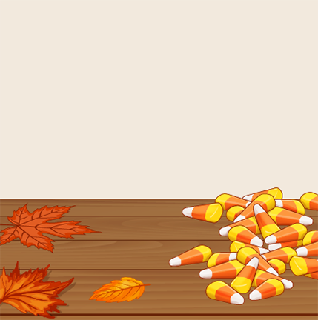  9:00 AM Greetings and Puzzle Packet Pass  10:00 Coffee Talk  10:30 Hallowed Halloween  11:15 Remembering Costumes  11:45 Exercise  2:00 Movie and Popcorn  4:00 Halloween Fill-In
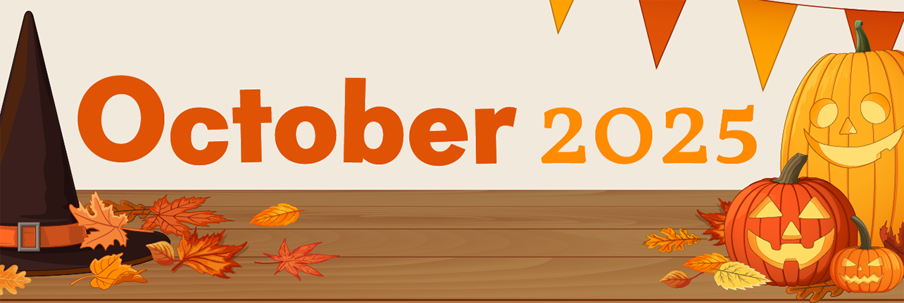
*Activities are Subject to Change* 7250 Old Oak BLVD., Middleburg Hts. 440-243-7888

